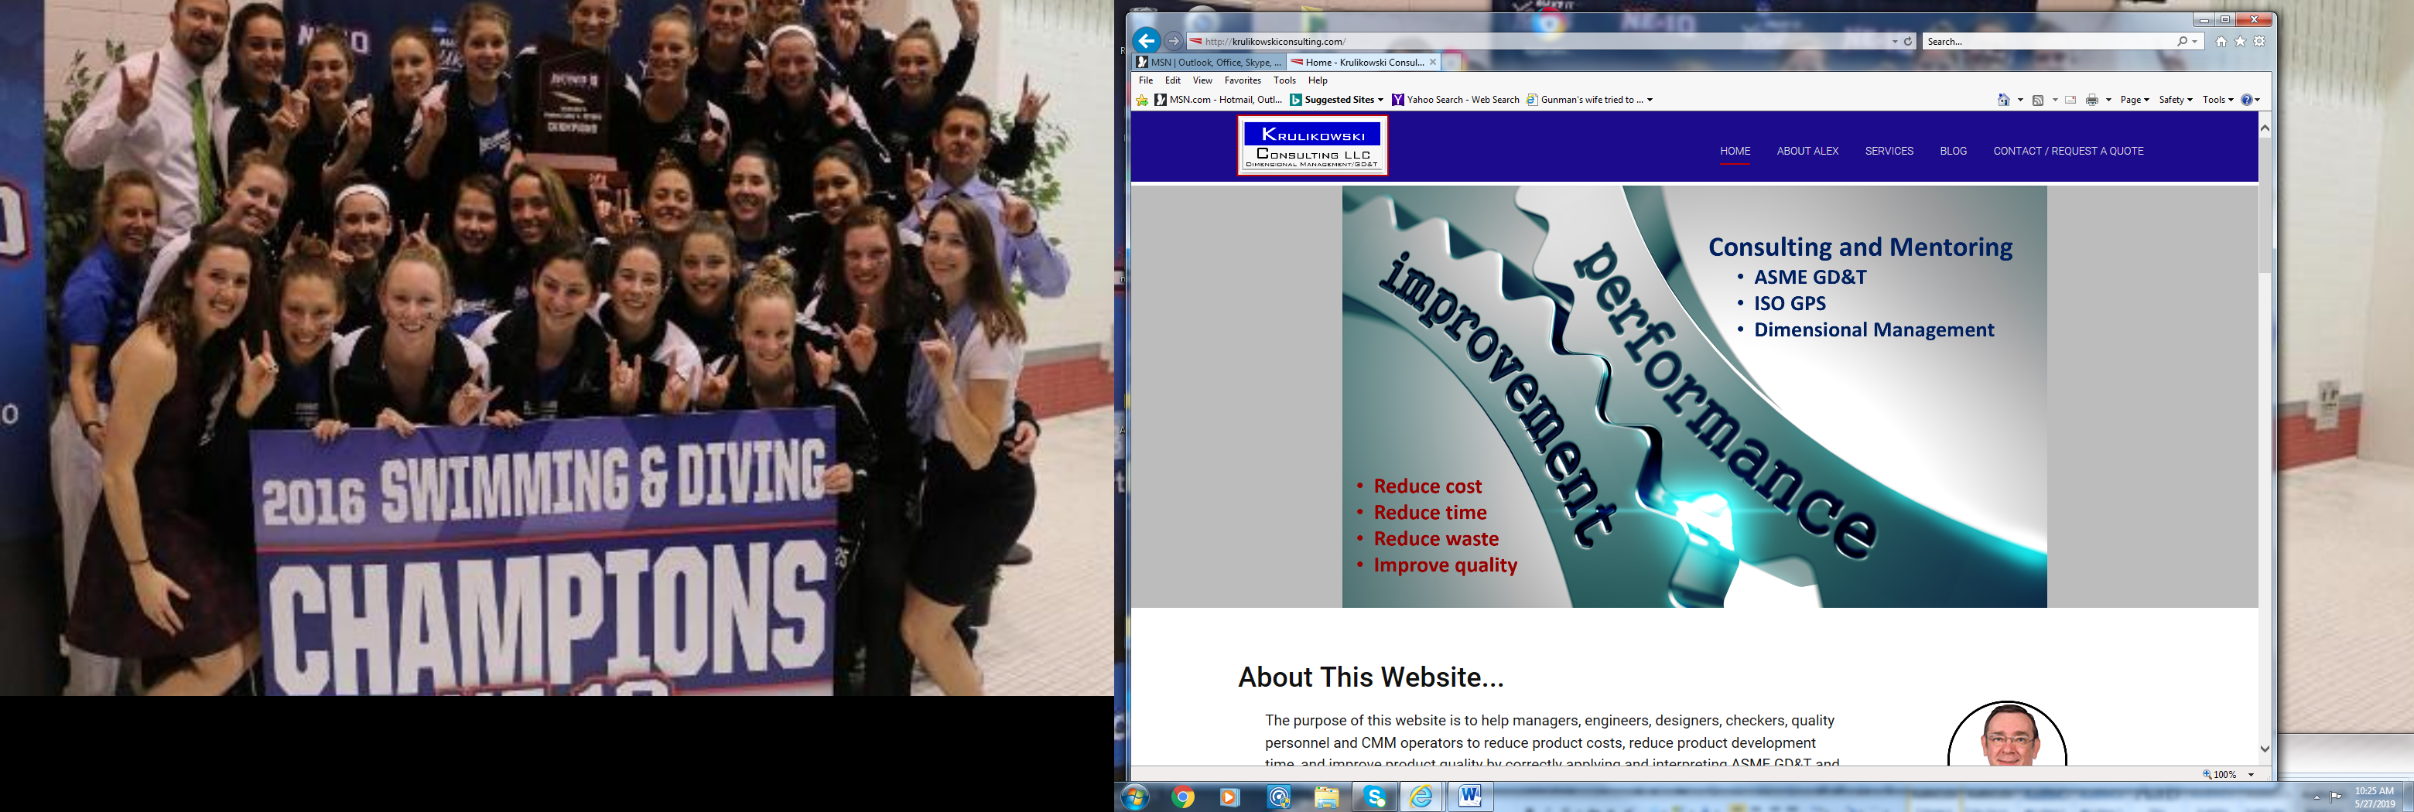

My goal is to help managers, engineers, designers, checkers, quality personnel and CMM operators reduce product costs, reduce product development time, and improve product quality by correctly applying and interpreting ASME GD&T standards and various dimensioning methods.

Proper use of standards and a common dimensional engineering process will eliminate many product related problems and lower production and inspection costs.

​

GD&T Mentoring

Had GD&T training but still not confident when tolerancing your drawings?

Want guidance for your GD&T team?

Having disagreements on how to tolerance your parts?

My mentoring services can provide expert help with your drawings.

Want to know more about ASME standards?

The current situation in many companies - In my travels, I see numerous examples of drawings with poorly defined parts, overly restrictive tolerances or ambiguous tolerances. And when drawings are clear and correct, they are often misinterpreted by downstream users.

Even when companies have had GD&T training, it helps a little, but, it often doesn't solve many of the on the job problems. Training is often packed into a two or three day marathon experience, like drinking from a firehose. These rapid fire training experiences are not very effective and studies show that 80-90% of the content is often forgotten within a few weeks.

GD&T training is helpful, but, it teaches mostly content. But what is needed to make a lasting change is content plus on-the-job guidance and feedback. This includes: the importance of standards, how to dimension parts to protect their intended functions, and how to verify tolerances.

​What is GD&T mentoring? - Mentoring is a technical activity that involves working with your drawings. The results from mentoring are usable on your project. Mentoring ensures that part tolerancing is clear, standard compliant and functional.  Mentoring is an excellent follow-up to GD&T training - it is clearly the best way to ensure that the material learned in a workshop is properly applied and integrated into your dimensional management process. Mentoring may be: an expert resource for your GD&T group, a source for understanding the ASME standards activities, guidance on dimensioning approaches, review of measurement methods, etc.

Benefits of mentoring - The benefits of mentoring can impact many areas of your organization.

- Anticipates problems instead of reacting to problems.

- Eliminates vague tolerances and many common drawing errors.

- Focuses on creating part tolerances that protect the function of your parts..

- Helps to create a link between the part functional requirements and the tolerances.

- Reduces product development time.

- Lowers production and gaging costs.

- Improves the inspection process of part tolerances.

- Reinforces GD&T training content and shows how to apply GD&T on your products.

Hire Alex as your virtual mentor today - Let me work with your staff on a long-term basis, helping them to become truly proficient in applying and understanding tolerancing on your engineering drawings. My oversight and guidance will help the tolerancing process to become the successful long-term solution you need.

Consulting

Parts don't fit or function?

Disputes over part acceptance?

Supplier disputes?

Need help defining or improving your dimensional engineering process?

My consulting services can help with all of these types of problems.

My goals for consulting - I help companies to reduce waste by improving their geometric dimensioning and tolerancing (GD&T) on their drawings and their dimensional management process.

The results are typically: reduced time to production, fewer changes after start-up, lower product costs, increased product quality.

As I work with companies from many industries, I continue to see vast amounts of time, resources, and money wasted. Often because the employees do not define or inspect parts properly, or the organizations' dimensional management process is flawed.

**My approach to consulting -** I focus on understanding your business objectives and the issues and obstacles in your organization before offering solutions. When you contact me, I will probably ask you a long list of questions designed to help me understand the objectives you want to achieve, the issues you want to explore, and obstacles you want to overcome. It may seem like my questions challenge the organizations judgement. In the past some clients rushed to the wrong solutions, because they didn't thoroughly understand the issues and obstacles preventing them from reaching their goals. I don't want to do this to you. I don't want to offer proposals until I have confidence that they will benefit your organization.

Every company is unique and there is not a single solution for improving dimensional management, a cookie cutter approach leaves a lot of opportunity sitting on the table.

A system approach - It is important to document the dimensional management process and get buy-in from the various parts of the organization. By using a system approach to dimensional management, great improvements can be realized in reduced time to production, fewer changes after start-up, lower product costs, increased product quality.

As Deming once said...  
           " Management's job is to optimize the whole system"

Expert help is available - If you think your organization could use some guidance in geometric dimensioning and tolerancing and dimensional management, then why not contact me for an initial consultation?